**Title:** On Causal Decision Making

**Presenter:** Rui Song

**Abstract:** Decision making is a fundamental aspect of human behavior. Effective decision making can lead to better outcomes, which requires an in-depth understanding of the causal relations between actions, environments, and outcomes. In this talk, we will surface three essential components of decision making through a causal lens: 1. identifying causal relationships through causal structural learning; 2. understanding the effects of these relationships through causal effect learning, and 3. applying the above knowledge to inform decision-making through causal policy learning. Key ideas and methods will be discussed, accompanied by real-world examples to illustrate the application.

**Short bio:** Rui Song is a **senior principal scientist** at Amazon. She got her PhD in Statistics from University of Wisconsin in 2006 and has been a faculty member at North Carolina State University since 2012. Her research interests include reinforcement learning, causal inference, precision health and knowledge graph. Her research has been supported as principal investigator by National Science Foundation (NSF) including the NSF Faculty Early Career Development (CAREER) Award. She has served as an associate editor for several statistical journals. She is an elected Fellow of the American Statistical Association and Institute of Mathematical Statistics.

**Notes**:

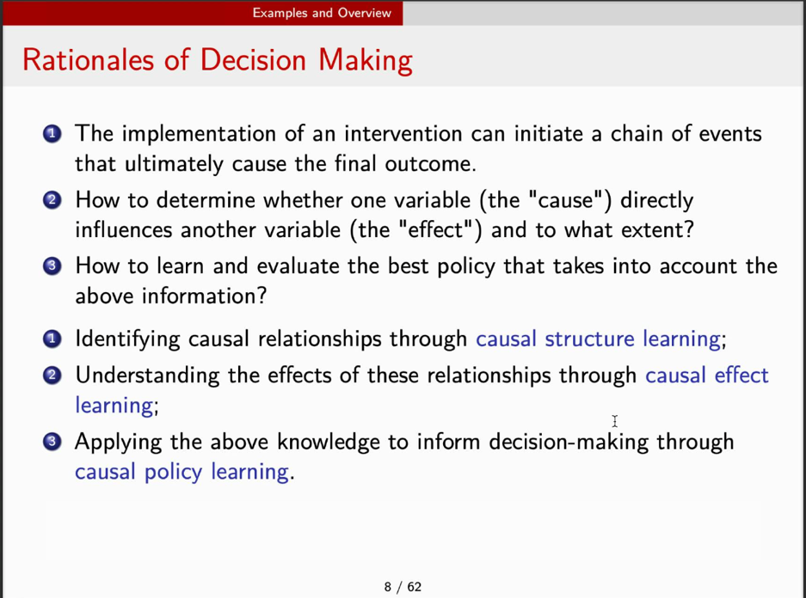

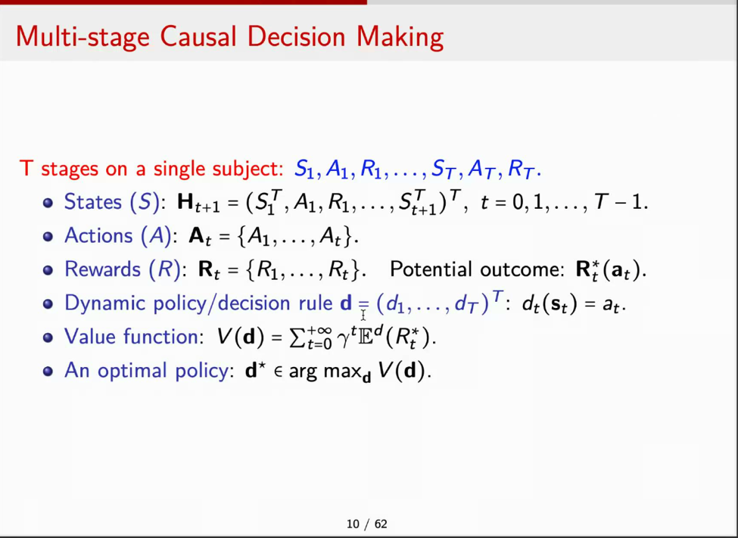

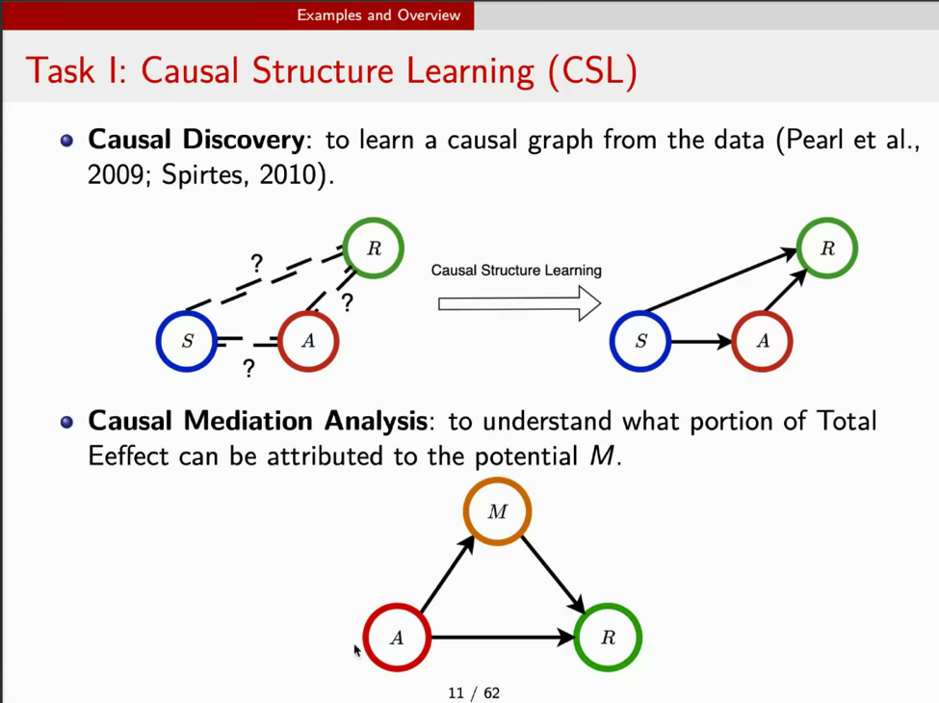

Other Way to Estimate the Treatment Effect: A/B Testing

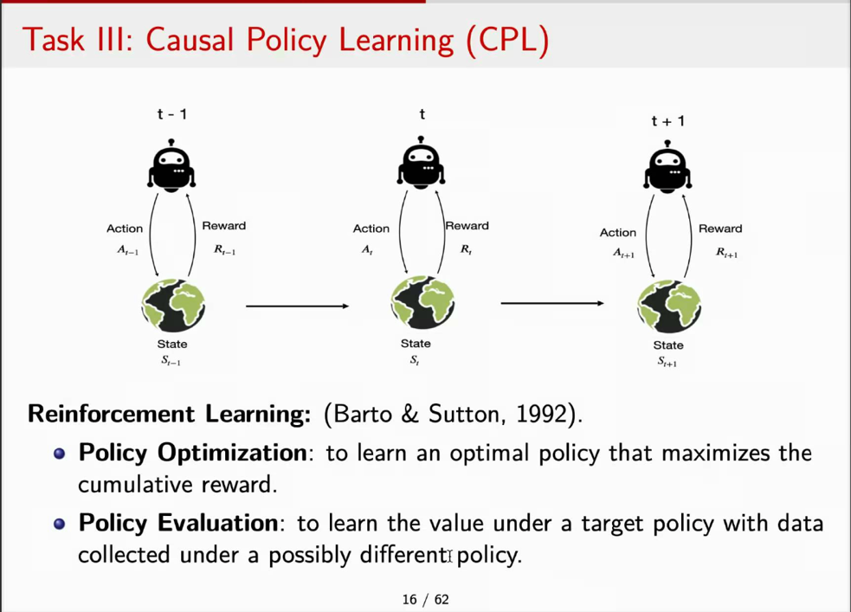

RL in Text Generation

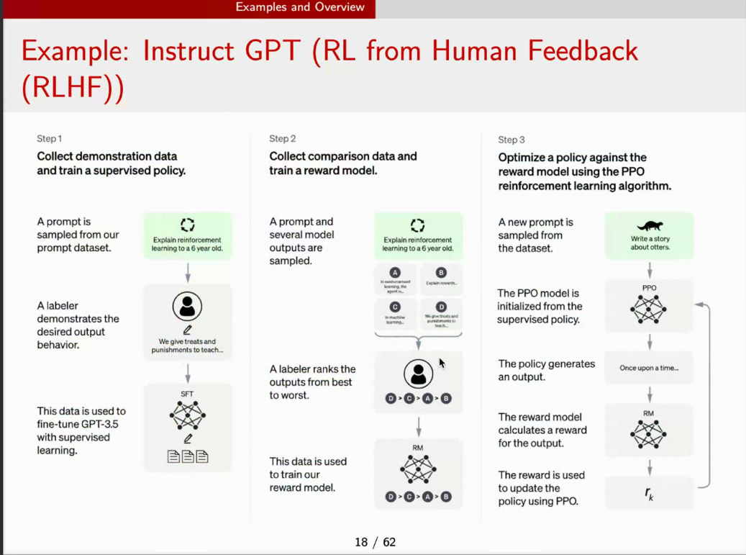

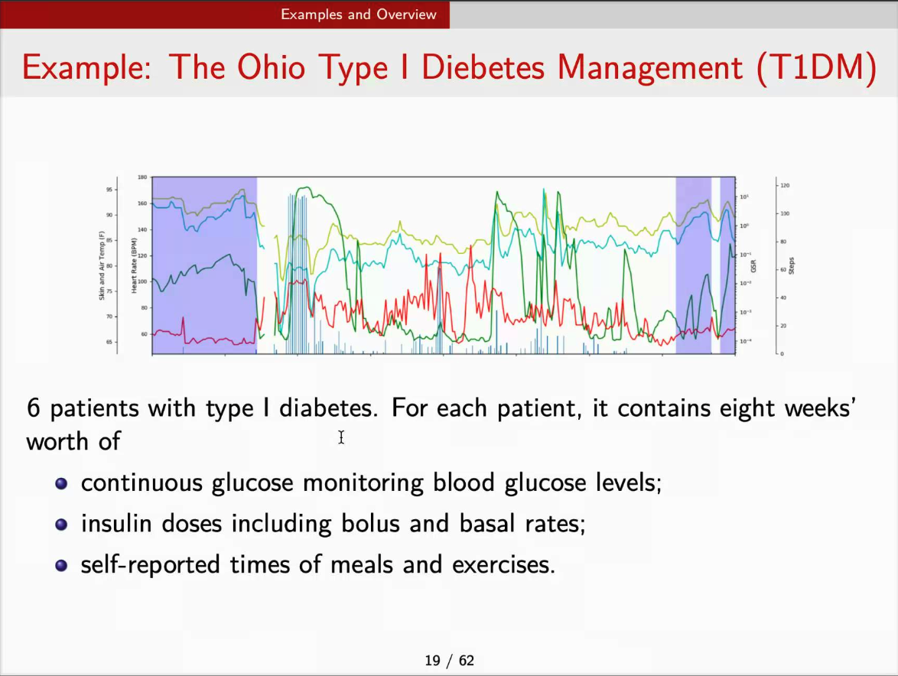

I am not trying to rename all those traditional mathematical models. What I am trying to do is to using a framework to connect all the necessary method into a framework to do the causal decision making.

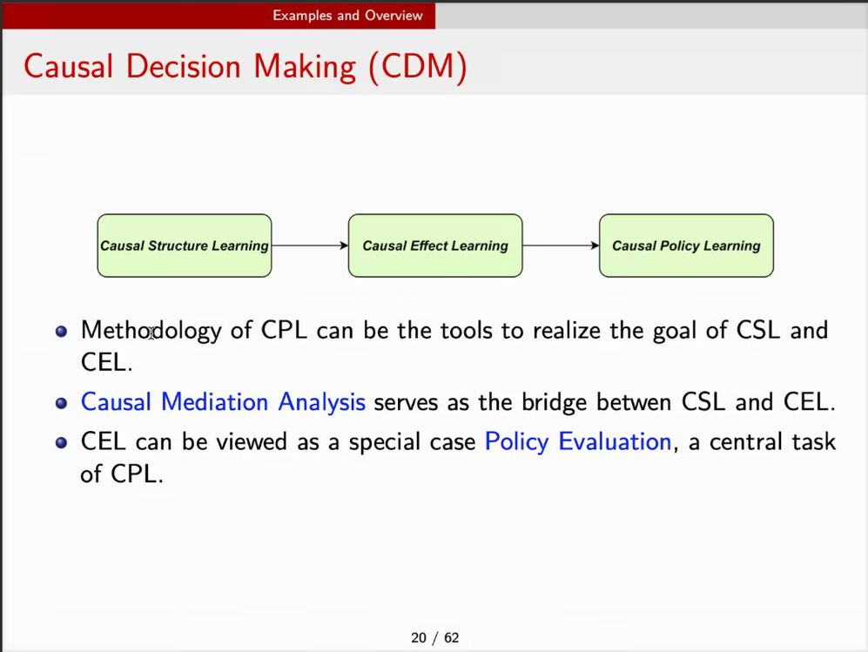

II. Major Paradigms

Roadmap

